PROGRAM-4

Q. Design and implement an algorithm to evaluate an arithmetic expression which may be in any form (infix, postfix, prefix), and demonstrate its working with suitable examples.

- Evaluation of POSTFIX expression.

- Theory:

Postfix Expression:
When the operator is written after the operands, then it is known as postfix notation. Operand does not have to be always a constant or a variable; it can also be an expression itself.

The syntax for postfix notation is given below:
<operand> <operand> <operator>
Example:
∗ + a b + c d
//---------------------------------------------------------------------------------

Example: Evaluate the given postfix expression:

a) 6 2 3 + - 3 8 2 / + * 2 $ 3+

Symbol Scanned | Stack
6 | 6
2 | 6,2
3 | 6,2,3
+ | 6,5
- | 1
3 | 1,3
8 | 1,3,8
2 | 1,3,8,2
/ | 1,3,4
+ | 1,7
* | 7
2 | 7,2
$ | 49
3 | 49,3
+ | 52

The result thus obtained is 52.

//---------------------------------------------------------------

- Algorithm:

Step-1: Scan the expression from left to right.
Step-2: If we encounter any operand in the expression, then we push the operand in the stack.
Step-3: When we encounter any operator in the expression, then we pop the corresponding operands from the stack.
Step-4: When we finish with the scanning of the expression, the final value remains in the stack.
//-----------------------------------------------------------------------
- Code:

#include<stdio.h> //header files are included
#include<string.h> //string.h to use all string functions
#include<ctype.h>

int stack[50]; //a stack of size 50 is initialized
int top=-1; // top value of the satck is initialized to -1
void push(char item) //push function to push the values into the stack
{
stack[++top]=item; //item is pushed into the stack top
}
char pop() // function to pop the items from the stack
{
return stack[top--];
}

// evaluation of postfix expression

int evaluate(char postfix[]) //evaluate function to evaluate the POSTFIX expression
{
char ch; //ch is initialized of character data type
int op1,op2; // two operators op1 and op2 are declared
int i=0;
while((ch=postfix[i++])!='\0') //loop to check if the condition is not equal to null character
{
if(isdigit(ch)) //isdigit is used to check whether the entered input is digit or not.
{
push(ch-'0'); //if it is a digit then it is pushed to the stack
}
else
{
// pop two operands
op2=pop(); //if the condition is fasle, then pop two operands
op1=pop();
}

switch(ch) //switch case to perform the task of evaluation of POSTFIX expression
{
case '+': push(op1+op2);
break;
case '-': push(op1-op2);
break;
case '*': push(op1*op2);
break;
//it is done for addition, subtraction, multiplication and division
case '/': push(op1/op2);
break;
case '^': push(op1^op2);
break;
}
}
return stack[top]; //the top value of the stack is returned after performing the evaluation
}

void main() //main function
{
char postfix[30]="123*+"; //postfix expression is declared of size 50 and a random expression is given by the user
printf("The postfix expression is %s \n",postfix); //the postfix expression is printed on the console
printf("Evaluation of postfix expression is %d \n",evaluate(postfix)); //the evaluated answer is displayed on the console
}
//END OF THE PROGRAM

//-----------------------------------------------------------------------------------

“SCREENSHOT OF THE OUTPUT”

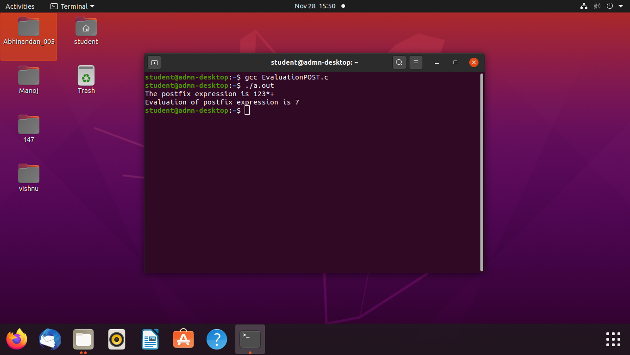

- Evaluation of PREFIX expression.

- Theory:

Prefix expression:
Another way to describe anything is with a prefix notation, which does not require knowledge about precedence or associativity but does when used with an infix notation. It is also known as polish notation. In prefix notation, an operator comes before the operands.

The syntax of prefix notation is given below:
<operator> <operand> <operand>
Example:
a b + c d + ∗

//-----------------------------------------------------------------------------------------------

Example: Evaluate the given PREFIX expression:

+, -, *, 2, 2, /, 16, 8, 5
Let’s reverse the given prefix expression.
Expression: 5, 8, 16, /, 2, 2, *, -, +

Symbol Scanned | Stack
5 | 5
8 | 5, 8
16 | 5, 8, 16
/ | 5, 2
2 | 5, 2, 2
2 | 5, 2, 2, 2
* | 5, 2, 4
- | 5, 2
+ | 7

The result obtained is 7.

//-----------------------------------------------------------------------------------
- Algorithm:

Step 1: Initialize a pointer 'S' pointing to the end of the expression.
Step 2: If the symbol pointed by 'S' is an operand then push it into the stack.
Step 3: If the symbol pointed by 'S' is an operator then pop two operands from the stack. Perform the operation on these two operands and stores the result into the stack.
Step 4: Decrement the pointer 'S' by 1 and move to step 2 as long as the symbols left in the expression.
Step 5: The final result is stored at the top of the stack and return it.
Step 6: End

//----------------------------------------------------------------------------------
- Code:
#include<stdio.h> // header files are included
#include<string.h>
#include<ctype.h>

//---------------------------------------------
char stack[50]; // a stack of character type has been declared
int top=-1; // initialize top to -1
//----------------------------------------------

void push(int item) // function for push operation
{
stack[++top]=item; // item is pushed into the top of the stack
}

//---------------------------------------------

char pop() // function for pop function
{
return stack[top--]; // stack of top is returned after popping an element
}
//----------------------------------------------

int isoperand(char c) // function to check the given symbol is operand or not
{
return isdigit(c); // the function returns whether it is digit or not
}
//-----------------------------------------------------------------------------
int prefixEval(char exp[]) // function to evaluate prefix expression
{
int i; // i is initialized
int a,b; // a and b are initialized as operands
for(i=strlen(exp)-1;i>=0;i--) // start of for loop and checking the length of the strength
{
if(isoperand(exp[i])) // an operand is being searched in the expression
{
push(exp[i]-'0'); // a the expression is pushed into the top of the stack
}
else
{
a=stack[top]; // the top element is stored in a
pop(); // top element is popped and is stored in a
b=stack[top]; // the top element is stored in b
pop(); // the next element is popped and is stored in b
switch(exp[i]) // switch statement to evaluate the expression.
{
case '+': push(a+b); // addition
break;
case '-': push(a-b); // subtraction
break;
case '*': push(a*b); // multiplication
break;
case '/': push(a/b); // Division
break;
}
}
}
return stack[top]; // return top of the stack
}

//---------------------------------------------------------------------------------
int main()
{
char exp[50];
int i;
printf("Enter the prefix expression:\n");
scanf("%s",exp);
printf("The evaluated prefix expression is %d",prefixEval(exp));
return 0;
}

//END OF THE PROGRAM

//--------------------------------------------------------------------------------

“SCREENSHOT OF THE OUTPUT”

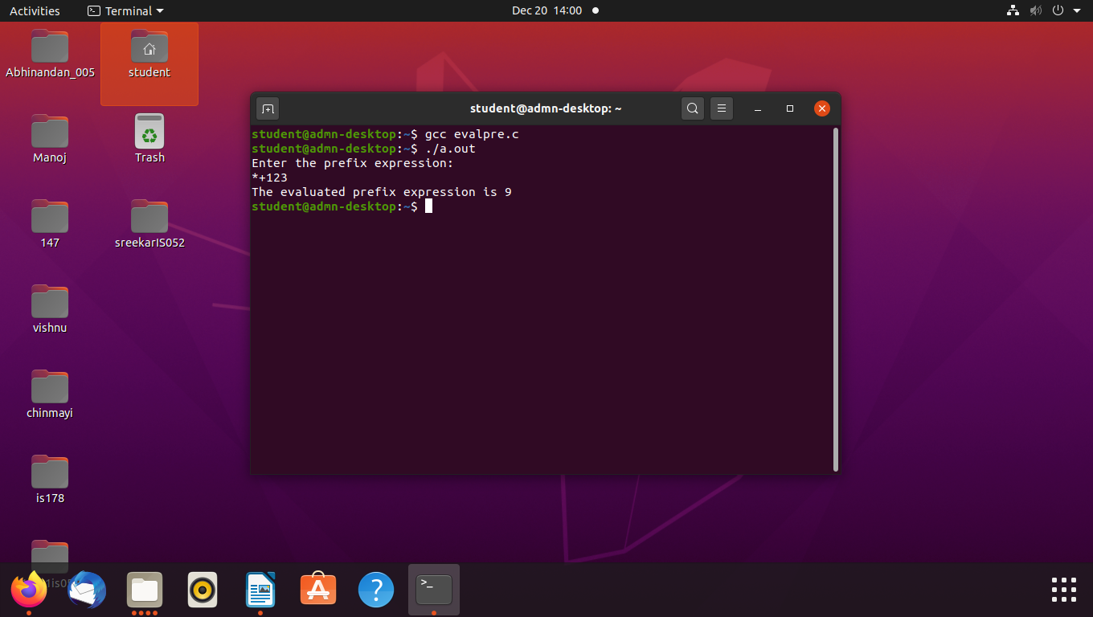
//---------------------------------------------------------------------------------

- Evaluation of INFIX expression.

- Theory:

An infix expression can be evaluated as same as of a simple calculator. This could be done in 4 ways:

- Using the switch statement
- Using do-while loop and switch statement
- Using if-else statement
- Using functions and switch statements

The below algorithm and code is done by using only the SWITCH statement.

//--------------------------------------------------------------------------------

- Algorithm:

Step-1: Create the four variables a, b, res, and op. The variables op, which accepts the operator as an input, result, which stores the calculation's outcome, and a and b which stores the values or operands.
Step-2: Take the operands' inputs, operator.
Step-3: To verify the operator, use switch cases or conditional statements.
Step-4: Show the outcome in accordance with the operator.
Step-5: Exit the program

//---------------------------------------------------------------------------

- Code:

#include <stdio.h> // header files are included

int main() { //main function

char op; //operator op is declared
int a,b; //operands a and b are declared
int res; //res to store the result
printf("Enter an operator (+, -, *, /):\n");
scanf("%c", &op); //user enters the opertor and specifies the operation to be performed
printf("Enter two operands:\n");
scanf("%d %d",&a,&b); //user enters the operands

switch (op) {
case '+':res=a+b;
break; //switch statement to perform the operations
case '-':res= a-b;
break;
case '*':res=a*b;
break;
case '/':res=a/b;
break;
// operator doesn't match any case constant
default:
printf("Error! operator is not correct\n"); //invalid operator
}

printf("The result is %d",res); //result is printed.

return 0;
}
// END OF THE PROGRAM

//------------------------------------------------------------------------------

“SCREENSHOTS OF THE OUTPUT”

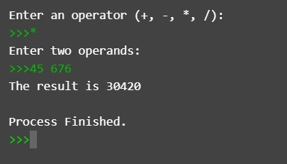

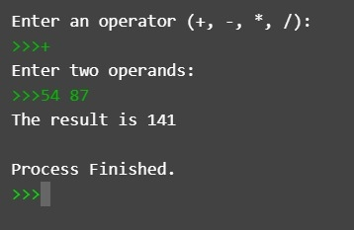

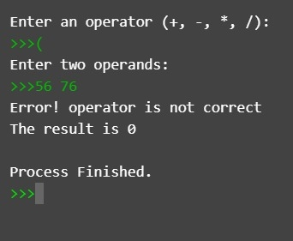

*********************************END************************************

